Assignment 15 (Spring 2025)

Problem 1
Solve the radial wave equation on a circular membrane with c = 1, R = 1, zero initial velocity, and initial displacement u(r, 0) = f(r), where
Additionally, find all the harmonic frequencies and the radius of each of the (inner) nodal circle for each mode (m) of the solution.

Problem 2
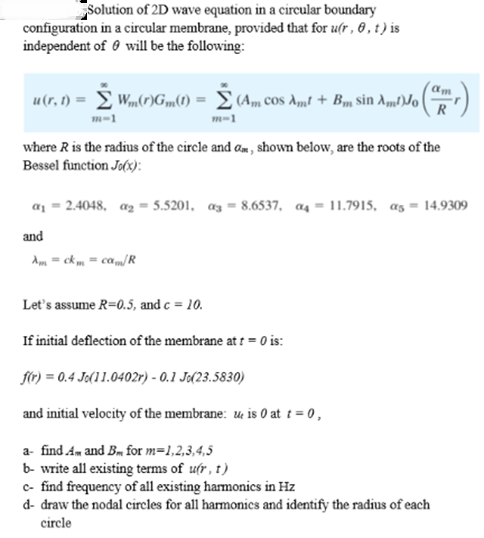

Problem 3
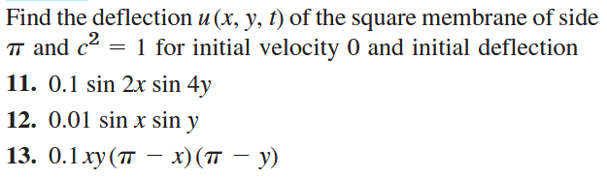

Problem 4
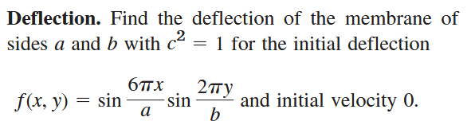

For Reference:

